Front-end Developer - Remote Task

|  |  |
| --- | --- |
| Task Title | Design to Reality |
| Task Duration | 24 hours |
| Technologies to be used | React, SASS |
| End product | Source code/Repo to be sent over |

The Design

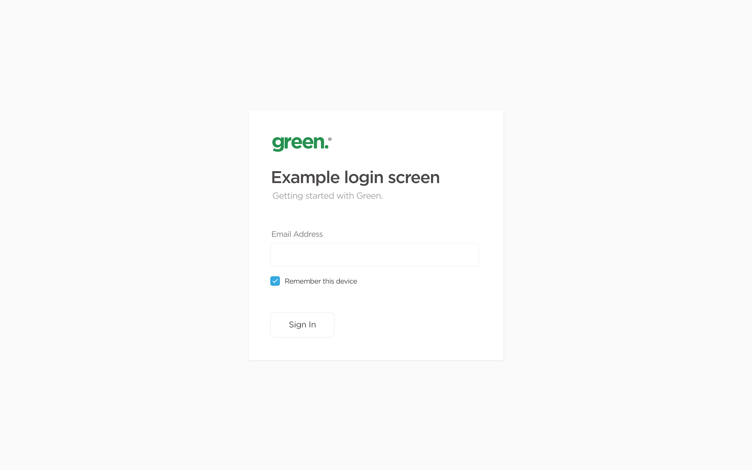

<https://green.cdn.energy/branding/logo-r.svg>

Font family: Gotham

The Task

* Create the design above using the technologies set.
* Considerable thoughts
  + Mobile friendly
  + Interactivity
  + Fonts
  + Padding
  + Shadowing